Sucess Stories: Smt. Ramjiyayi, Kodiyaghat, S. Andaman

A hardworking goat farmer of South Andaman
Smti. Ramjiyayi, a 56 years old lady farmer of Kodiyaghat, South Andaman started goat farming with 5 goats about four years back. Presently, she is having a total of 23 goats which are being maintained in wooden shelter with cemented flooring and steel sheet roofing. During the field survey by the project staffs of ACIRP on Goat Improvement, she was explained the mandates of the project and gladly agreed to be included in the project. She showed very much interest in scientific goat rearing and contacted the ICAR-CIARI for technical advice for improving the productivity in goats. ICAR-CIARI Scientists visited Smti Ramjiyayi’s house and suggested the technical guidance regarding, feeding, housing, timely deworming, health management and selection of superior germplasm. She has started feeding mineral supplementation and doing regular deworming which caused great impact in term of body weight gain and reproductive efficiency. With the constant support and guidance, she has increased her stock to 23 goats and is very much happy about her progress. She informed that they are earning approximately Rs. 50,000/- per annum by selling of goats. With the earnings from goat farming now she is supporting her family and goat farming is now major part of her family’s livelihood.
She also had a cows which she sold recently in Rs. 20,000/-.
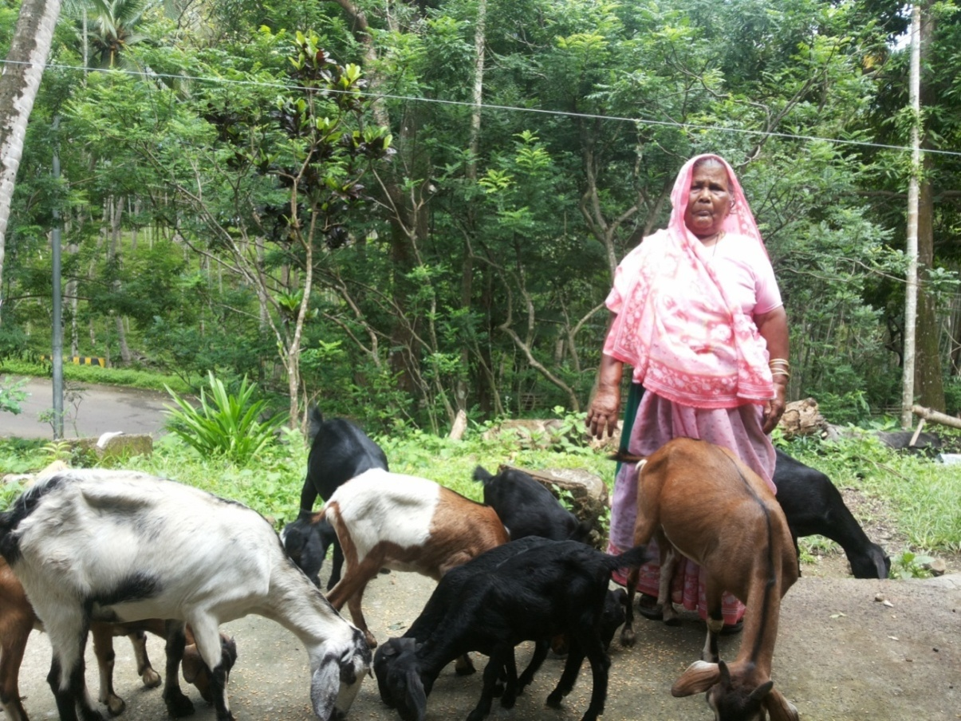
Details of Management:
After adopting scientific goat farming now she is managing her flock in a very systematic way. Every morning she gives feed (little supplementation of wheat/rice.) to her goats with mineral supplement (provided from ICAR-CIARI, Port Blair) and then allows them for grazing in forest /open field area near to her house for 5 to 6 hrs. The staffs of AICRP on Goat Improvement visited her farm at regular intervals and recorded observation of body weight and biometric dimensions. She also advised for proper cleaning and management of goat shelter for prevention of diseases. We also provided the medicines time to time for good health of her goats.
She was awared with importance of feeding of colostrums to the kids, sale of goats on the basis of body weight, disadvantages of inbreeding in the flock, importance of identification of goats and keeping records, concentrate feeding with mineral mixtures and regular deworming schedule etc.
Technology adopted:
She was given the technical and managemental guidance regarding feeding, low cost houses with good ventilation facility (with locally available material), timely deworming, health management and selection of superior germplasm etc. by the Scientists of ICAR-CIARI, Port Blair. By using mineral mixture with feed and timely deworming she got improvement in body weight gain and reproduction efficiency in her goats. From ICAR-CIARI we provided superior quality of buck for breeding purpose for quality progeny of kids. The fodder cuttings were also distributed to her. Also before adopting technologies from ICAR-CIARI, Port Blair, her flooring was simply grounded. We advised her for cemented flooring with fibre sheet roofing. She is also using a herbal based lotion for control of external ticks under trial developed by Animal Science Division.
Impact of Technology:
After adopting the technology from ICAR-CIARI, Port Blair under the project AICRP on Goat Improvement, now she is supporting her family and goat farming is major part of her family’s livelihood. She is earning approx. Rs. 50,000/- annually by selling bucks only. With the constant support and guidance of ICAR-CIARI, she has increased her stock to 23 goats and very much happy about the progress.
Economics:
Before adopting the technology from ICAR-CIARI, Port Blair under the project AICRP on Goat Improvement, her annual income from goat faming was approx. Rs. 35,000/- only which get increased upto Rs. 60,000/- within 2 years and Rs. 20,000/- by selling of cow.

